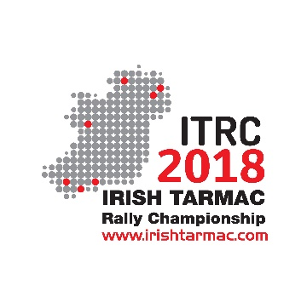

13th March 2018

The Directors of TROA have announced that the proposed arrangement for delivery of sponsorship Tarmac Rally Championship from 2018 onwards by THL (Tipp Holdings Limited/Dance to Tipperary) will not proceed.
This is unfortunate and comes after intensive discussions between TROA and THL. However, we wish THL the best going forward.
The Irish Tarmac Rally Championship will be unaffected by the change and will proceed fully as planned with the first round set for West Cork on St. Patrick’s weekend in Clonakilty.
Interest and registrations are already very strong, and we look forward to a successful and competitive 2018 Championship. TV coverage has been secured and the Championship will be broadcast in Ireland, the UK, most other European countries, Australia, New Zealand, and North America. Despite some negative comments recently on some social media platforms, West Cork boasts a superb entry and promises to be an exciting beginning to the 2018 ITRC.
TROA will be issuing further press releases over the coming days.
Paddy Flanagan
Championship Manager

